Signs Your Pet May Have Allergies
Drs. Foster & Smith Educational Staff

Marley, a Springer Spaniel, was always licking and chewing at her feet. Her owner, Lin, didn't know what to do about it, but she knew it was driving her 3-year-old dog crazy (not to mention turning Marley's snow-white feet dark burgundy). Lin decided to take her suffering spaniel to her veterinarian for some answers.
Lin had guessed Marley chewed at her feet because they itched so much. Was Marley having a reaction to something she stepped in? Did she have bug bites? What Lin didn't know until she saw her veterinarian was that itchy feet is actually a classic symptom her pet was suffering from an allergy to pollen.
Like Lin, many animal lovers don't know the signs of pet allergies because dogs and cats show different reactions to some of the same things we're allergic to. Grass pollen, for example, made Lin sneeze and her eyes water. That same pollen, it turns out, made her spaniel's feet itch.
Depending on the type of allergy, your pet may exhibit different symptoms. Although pets occasionally exhibit watery eyes and some sneezing, the most common reaction is scratching. Constant scratching may lead to raised infected welts, open sores, and loss of hair. Ear infections are also common in dogs with allergies.
Pets who are affected by allergies may suffer their entire lives; typically symptoms worsen as they get older. We can help alleviate some of that suffering by knowing the signs of allergies and finding the right type of product relief for the symptoms.
Types of Allergies That Affect Pets
There are four types of allergies that can affect your pet. Allergies caused by things your pet inhales are termed airborne allergies. Common sources are pollens, molds, and dust mites. Allergies that result from flea-bites are referred to as flea allergies or flea-bite dermatitis. Certain allergies occur from items your pet ingests, and are typically called food allergies. Contact allergies are caused by something your pet comes in direct contact with, such as carpet fibers, plastics, and other things. Contact allergies (plastics, carpet fibers, detergents) are far less common than inhalant allergy and flea allergy dermatitis in pets.
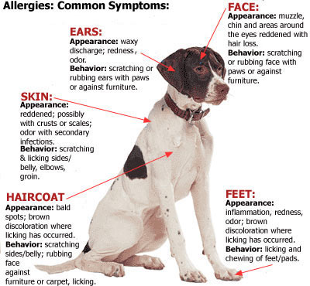
Contact Dermatitis
Less common allergies include contact dermatitis, which include allergy to carpets, cleaners, or plastic. These allergies may cause:
- Red itchy bumps or blisters on sparsely-haired areas of the skin and those exposed to the allergen such as the belly, feet, or muzzle
- Intense scratching
- Hair loss (in chronic conditions)
Food Allergies
Food allergies account for about 10% of all allergies in dogs and cats. Food allergies may show up concurrently with allergies to pollen, dust, etc. Symptoms include:
- Itching, especially face, feet, trunk, limbs and anal area
- Ear problems, often yeast-related
- Skin infections that respond to antibiotics, but then recur as soon as the antibiotic therapy ceases
Occasionally, dogs with true food allergies may have increased bowel movements and soft stool. Food allergies should not be confused with food intolerances, which are not true allergies, and generally cause diarrhea and vomiting.
Watching your pet go through the misery of allergy symptoms can be miserable in itself. If you suspect your pet has allergies, visit your veterinarian. The type of allergy and severity of the symptoms will determine how your veterinarian decides to treat them.
Next, read, " 7 Tips to Help You Care for Your Allergic Pet" for ways of making life a little more tolerable for your allergic pet.
Less common, but more severe allergic reactions include:
- Urticaria (hives)
- Angioedema (facial swelling)
- Anaphylaxis is a rare, life-threatening, immediate allergic reaction to something ingested or injected. If untreated, it can in some cases, result in shock, respiratory and cardiac failure, and death.
These symptoms usually appear within 20 minutes of being exposed to the allergen, which can include drugs, chemicals, insect bites, or something eaten.
If your pet has developed urticaria or if your pet has angioedema from an insect bite, you may want to discuss various options with your veterinarian. Your veterinarian may give you a prescription for an epi-pen which is a special syringe and needle filled with a single dose of epinephrine. If your pet has an anaphylactic reaction or severe angioedema, inject the epinephrine using the epi-pen and seek emergency veterinary assistance immediately. Be sure to take the epi-pen with you on any trips or hikes.

